

Internship Report

**Energy Monitoring Project: WYT Edge**

**Baboolull Yougesh**

Student of Big Data Analytics

Polytechnics Mauritius Limited

April 2020

# Acknowledgement

First of all, I would like to thank Mr Wafiik Aumeer, Maintenance Manager at Maurilait Production Limited who inspired me as well as coached me throughout the completion of this project. Mr Wafiik has guided me all the way till the end of the project. He was always here to listen as well as suggest me as a senior. Moreover, I equally thank Mr Zoubeir, my lecturer from Polytechnics Mauritius who was also very helpful and always ready to help. I also thank Polytechnics Mauritius to have given me the opportunity to put in practice my talent and knowledge in the industry. Lastly, I also thank every other people who contributed directly or indirectly to the completion of the project.

During my internship, I completed a main project, which is entitled “WYT Edge”. This is basically a Multiform Energy Monitoring System at Maurilait. At Maurilait, the Energie department has a technical team for energy monitoring.

Besides that, I also did small electronics projects and experiments which helped me in the completion of the main project. I did projects such as: Knight Rider Lights, Clap Switch, Light control via SMS, Dark-activated switch

I also worked on an AI Game Development in Python which I completed successfully. It is an N-puzzle game in which numbers are placed in a 3 x 3 square and the computer needs to rearrange the tiles in the correct order.

I also worked on a Remote Observatory Boat (ROB) Project where I built an Android App to push data into an online database and also built its website.

# Abstract

This Project has been completed during the internship period of Semester of Big Data Course. This project has been realised in collaboration with Maurilait Production Limited, which looked forward to implement such types of monitoring system. In this document, you will find the importance of monitoring and analysing energy consumption. It has been entitled: WYT Edge.

Furthermore, the WYT Edge project can be modified appropriately to adapt to many other situations related to monitoring. It has proved to be a great companion for technicians, boosting the time-consuming processes and making monitoring of energy a more smart and easy process.

Industry 4.0 is the trend towards automation and data exchange in manufacturing technologies and processes. WYT Edge has the capability to be a first step into Industry 4.0. Introduction of such technologies into the industry will help create smarter factories for efficient manufacturing.

Table of Contents

Acknowledgement 1

Abstract 2

Table of Figures 4

Introduction 5

Introduction to Maurilait Production Limited 5

Introduction to WYT Edge 6

Project Objectives 7

Project in Details 8

Automatic IOT System 8

Introduction 8

IOT Devices Used 8

Programming Part 13

Android APP 14

Introduction 14

Features 14

Programming 14

Snapshots 14

Web Interface 16

Introduction 16

How it works? 16

Resources used 17

Snapshots 17

Conclusion 19

GLOSSARY 20

List of Abbreviations 21

# Table of Figures

Figure 1: Maurilait Logo 5

Figure 2: Yoplait Logo 5

Figure 3: Candia Logo 5

Figure 4: Miko Logo 5

Figure 5: J logo 5

Figure 6: WYT Edge Logo 6

Figure 7: Arduino Uno 8

Figure 8: GSM GPRS SIM900 9

Figure 9: TFT Arduino Screen 1.8" 9

Figure 10: Mini Arduino Ethernet Shield 10

Figure 11: Temperature Sensor 10

Figure 12: IOT Sender Circuit 11

Figure 13: IOT Receiver Circuit 12

Figure 14: Sender Code in Arduino IDE 13

Figure 15: Receiver Code in Arduino IDE 13

Figure 16: Android Log in page 14

Figure 17: Android Fast Menu 14

Figure 18: Android Data input interface 14

Figure 19: Android Dropdown Menu interface 15

Figure 20: Android double check confirmation dialog 15

Figure 21: Android Data Display Menu 15

Figure 22: Android Data Display 15

Figure 23: WYT Edge Website 17

Figure 24:WYT Edge Panel 18

Figure 25: WYT Board 18

# Introduction

## Introduction to Maurilait Production Limited



Figure : Maurilait Logo

Maurilait Production Limited (MPL) has been the first company since 1976, to have created consumer demand for high quality industrially processed milk products. MPL is a member of the Eclosia Group and as a franchisee of internationally renowned brands such as Yoplait, Candia and Miko, MPL is committed to offering a wide range of quality products to Mauritians. In addition, MPL has a modern factory equipped with modern machinery which is a plus in production. Every day the technical team strives to make products tastier and healthier, so that the consumers are delighted. MPL also has a well-equipped analysis laboratory to ensure in-depth control of all treatment operations.

The most important department which we are directly concerned is the Energie Department which is the Maintenance department, available 24/7 to service the factory repairs and maintenance. At MPL, we have 6 energies, namely: Water, Waste Water Management, Refrigeration, Steam, Compressed Air and Electricity.

Brands Manufactured at Maurilait:

|  |  |  |  |
| --- | --- | --- | --- |
| Figure : Yoplait Logo | Figure : Candia Logo | Figure : Miko Logo | Figure : J logo |

## Introduction to WYT Edge

Figure : WYT Edge Logo



WYT Edge

WYT Edge is a multiform technology which boosts the process of Energy Monitoring. WYT Edge can be split into 3 different platforms:

1. Fully Automatic IOT system
2. Semi-Automatic Android App
3. Online web interface

When I started my internship at MPL, I analysed the monitoring process closely for one week, to figure out the time-consuming tasks which can be improved.

Energy is monitored every morning and every single day, a technician takes his notebook and pen and sets off to read the energy meters (Examples: water meters, gas gauges). The factory is quite big and an enormous amount of energy is consumed with so much production which also results in having a huge amount of energy meters for each department and section, such as there are over 70 water meters at MPL. So, after taking the meter readings, the technician gets back in his office and enters that data into an excel sheet, which takes quite a lot of time. Then, he uses excel formulas to calculate consumption and other required calculations. Lastly, each week a consumption report is prepared in the same excel which is verified by the Engineering Manager.

Too much time is lost with the above way of monitoring, which led us to the invention of WYT Edge.

In the fully Automatic IOT system, there is no requirement for human intervention. The system has been created in such a way that it captures the data and sends store it safely in an online storage.

The Semi-Automatic Android app is an android app which is replaces the technician’s notebook and pen as well as the excel sheet. The Android App supports the data entry and data display for 5 different energies, and is directly connected to an online storage.

The Online web interface includes the WYT Edge website, WYT Edge Panel, Online water data entries, Energy readings display, WYT Board and much more.

# Project Objectives

* **Effective Energy Monitoring**

Monitoring includes the capture, storage as well as analysis of data. WYT Edge allows technicians to capture data easily, store securely and allow analysis to be done graphically.

* **Time Effectiveness and Productivity**

The old method of energy monitoring took a lot of time to note down, type in the excel sheet and then create reports. Moreover, it does not allow the technician to focus on other important tasks. WYT Edge automates the time-consuming tasks, thus also granting the technician precious time to invest into productive maintenance or repairs.

* **Accurate and Flawless**

Undoubtedly, computers can process information more accurately and will produce flawless results. WYT Edge allows the process to be more error-free by reducing the number of times the technician types in readings or values.

# Project in Details

## Automatic IOT System

### Introduction

This is an IOT circuit built to automatically capture meter readings, calculate and store required readings or consumption and generate reports. The project has been realised using IOT devices like: Arduinos, GSM Modules, Sensors and TFT screens.

### IOT Devices Used

1. **Arduino Uno**

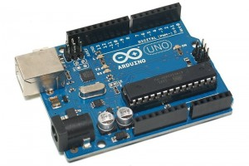

Figure : Arduino Uno

1. **GSM GPRS shield SIM900**

The GSM GPRS shield is particularly useful as it allows to:

* Connect to the Internet over GPRS network
* Send and receive SMS
* Place and receive phones calls

Its capabilities make it perfect for projects with Arduino like:

* Remote control of electronic appliances

*Example: Sending an SMS to turn something on;*

* Receive notifications

*Example: Send SMS to your cell phone if movement is detected in your house;*

* Receive sensor data

*Example: Send periodic SMS to your cell phone with daily weather data.*

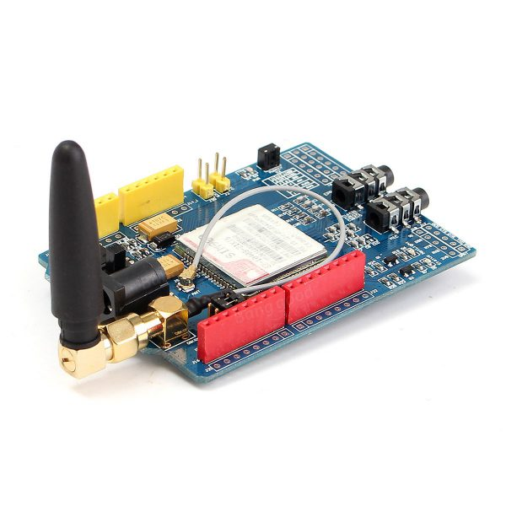

Figure : GSM GPRS SIM900

1. **TFT LCD Screen 1.8”**

The Arduino TFT screen is a backlit TFT LCD screen with a micro SD card slot in the back. Additionally, we can draw text, images, and shapes to the screen using special libraries. The screen's pin layout is designed to easily fit into the socket of an Arduino Esplora and Arduino Robot, but it can be used with any Arduino board. – arduino.cc (Official website for arduino).

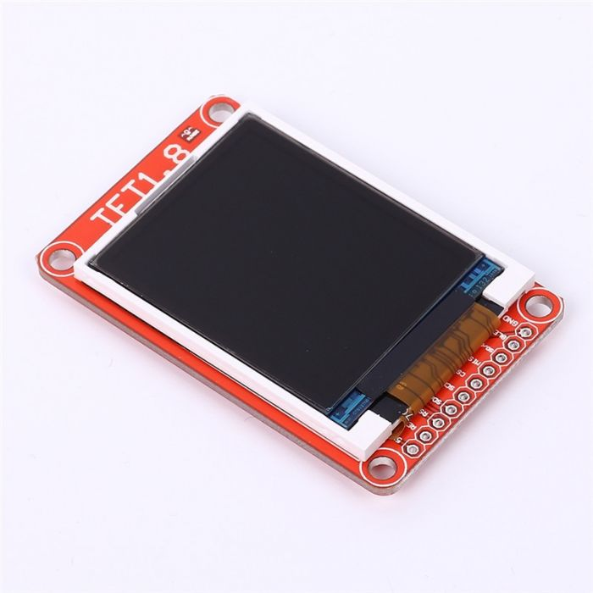

Figure : TFT Arduino Screen 1.8"

1. **Mini Arduino Ethernet Shield**

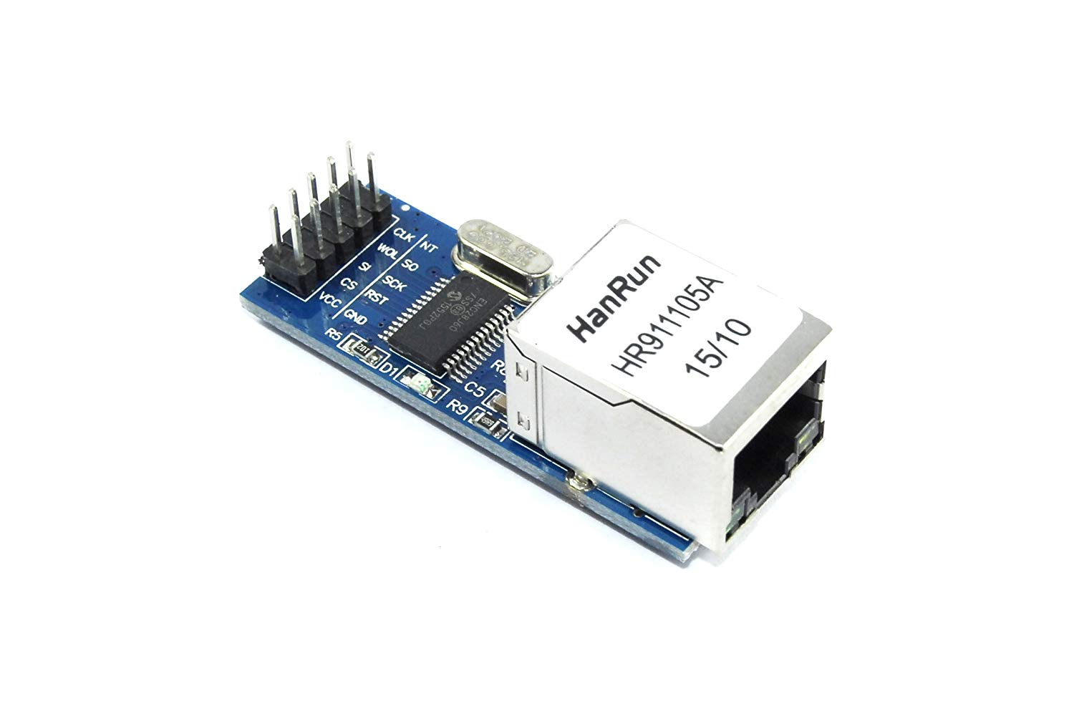The Mini Arduino Ethernet Shield HR 16/19 allows an Arduino board to connect to the internet. The module provides a network (IP) stack capable of both TCP and UDP. It supports up to four simultaneous socket connections.

Figure : Mini Arduino Ethernet Shield

1. **Sensor**

A sensor is a device that detects and responds to some type of input from the physical environment. The output is generally a signal that is converted to human-readable display at the sensor location or transmitted electronically over a network for reading or further processing.

In our project, we tested using a temperature sensor.

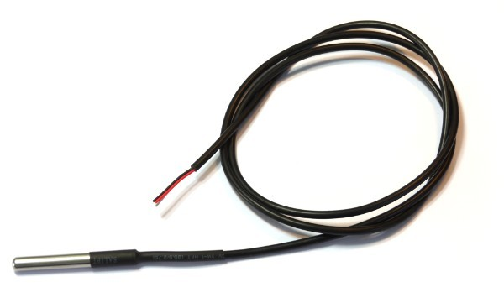

Figure : Temperature Sensor

#### Circuitry and Process

The system is split into 2 parts:

* 1. Sender
  2. Receiver

**Sender**

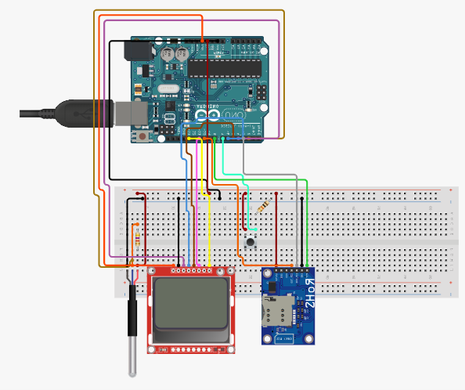The sender part will be present on field, that is, it will capture the readings and send it to the receiver’s end.

Figure : IOT Sender Circuit

**Circuitry Details:**

The schematic design of the sending party is given above as a reference and below is some information on the important connections. The design above was designed in circuito.io.

The temperature sensor has an analog wire connected to the A0 analog pin of the Arduino which sends the temperature information from the sensor to the Arduino.

The GPRS module has RX and TX pins which are connected to the Arduino digital pin 7, 8 respectively.

The LCD screen CS pin is connected to the Arduino digital pin 4.

**Process:**

The temperature sensor measures the temperature at a pre-set interval of 0.5 seconds. It sends the temperature reading to the Arduino. The Arduino only sends the temperature to the receiver when the button is pushed.

Upon a button push event, the Arduino take the last read temperature data and converts it to Degrees Celsius. The Arduino then displays the text to be sent to the receiver on the LCD screen and performs the AT Commands to send the message.

The AT commands are written to the GSM module which transmits the message via SMS to the receiver.

**Receiver**

The receiver part will receive the readings from the sender and will be connected to a LAN, allowing access to the database. The receiver part will handle the processing part, that is sending any alert if needed and storing data in an online database.

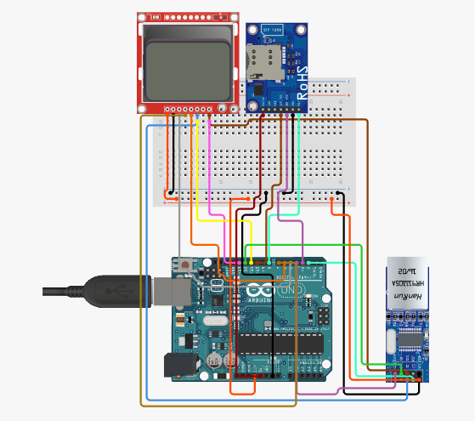

Figure : IOT Receiver Circuit

**Process:**

The GSM module receives an SMS. The SMS is broken into: SMS Status, SMS validity period, SMS submission report, Sender number, AT command, Storage type, SMS content, etc…

The Arduino at the receiver’s end breaks down the SMS message received and using the sender’s number, it authenticates the sender.

If the sender’s number is different from the pre-set number, no action is taken, otherwise, if the sender is authentic, the value is displayed on the LCD screen.

The value in converted from string to integer to be pushed to an online API. The program in the Arduino then does the http request through the ethernet shield to trigger an API. The API will push take the value from the Arduino and will push it to the connected database through php scripts.

### Programming Part

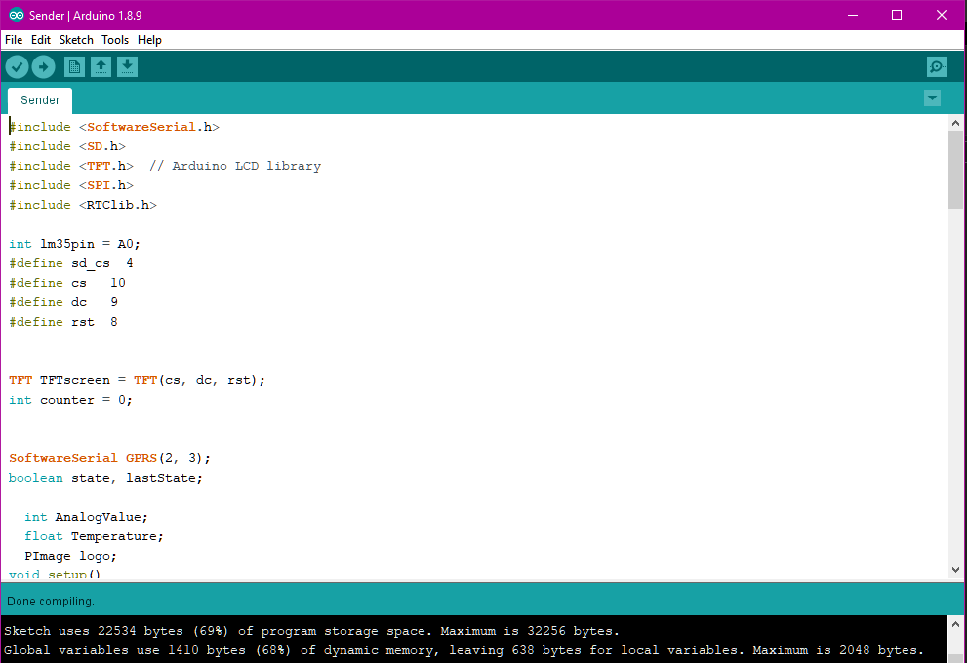The Arduino program has been coded in C++. Every device used has a library to be installed to be able to control that device. For some devices, there was a need to modify the original library because the devices were not from the original manufacturer, such as the TFT screen which has inverted colours for blue and red. After writing the program, the code is compiled in the Arduino IDE and uploaded to the Arduino board using the USB Arduino connector cable.

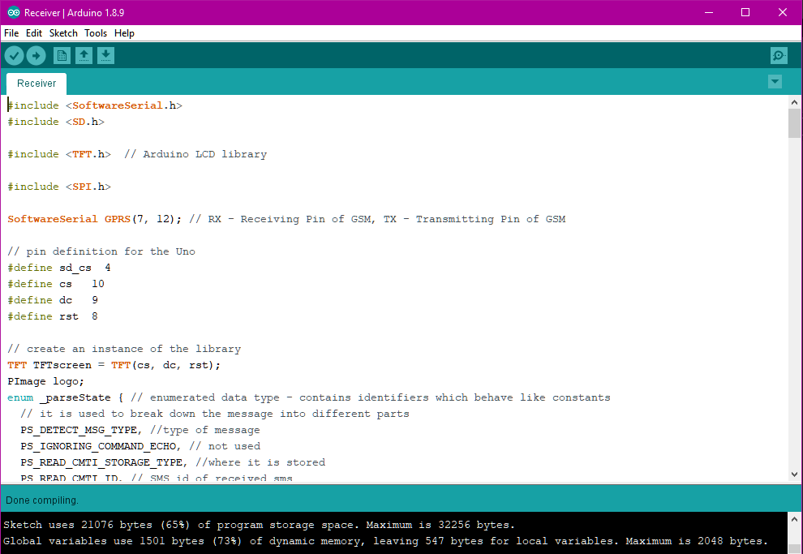

Figure : Sender Code in Arduino IDE

Figure : Receiver Code in Arduino IDE

## Android APP

### Introduction

WYT Edge is also available on the android platform. The Android app is a method that merges the process of logging readings on paper and typing it on an excel sheet. WYT Edge brings in new technology where the technicians can type the value on a mobile phone and through internet connection, the value can be pushed into an online hosted MySQL database.

### Features

* Log in page on start-up which requires special credentials to log in
* Connected to an online server via internet
* All energy readings entry can be made on the app which will be pushed to the database
* Simple and easy design for easy interaction
* The previous readings can be viewed in app

### Programming

The WYT Edge App has been coded in Java in Android Studio IDE. The app uses the concept of OOP to make app maintenance easier. WYT Edge APP has different classes for every activity in the app. It does HTTPS connection to our online virtual server where our APIs have been hosted. It is an internet dependent app which stores the information on a database in the virtual server online.

### Snapshots

|  |  |  |
| --- | --- | --- |
| Figure : Android Log in page | Figure : Android Fast Menu | Figure : Android Data input interface |

|  |  |
| --- | --- |
| Figure : Android Dropdown Menu interface | Figure : Android double check confirmation dialog |

|  |  |
| --- | --- |
| Figure : Android Data Display Menu | Figure : Android Data Display |

## Web Interface

### Introduction

The web interface includes:

* WYT Edge Website
* WYT Edge Panel
  + WYT Edge Admin Interface
  + WYT Edge Technical Interface
* WYT Board

The **WYT Edge Website** is simple website which provides details on the Energie team at Maurilait Production Limited and also links the WYT Edge panel for log in. The website also has a contact option which can send a mail directly to the mail inbox of WYT Edge.

The **WYT Edge Panel** is a log in interface to the required page depending on the credentials provided.

**WYT Board** is the interface for graphical view of the data. The graphs have been plotted using CanvasJs framework.

### How it works?

A virtual host server subscription has been purchased on Hosinger.com. After a lot of research, I found a cheap and reliable host which had what we needed: File storage, web hosting and database management

The WYT Edge panel is linked to the WYT Edge website. Upon sign in to the panel, the user credentials are validated to check the authenticity of the user. Based on the credentials, the user signs in to the required page. The administrator has special credentials to sign in to an admin page.

The Admin user has full control over the other users. That is, the Admin can add a new user, change password of a user and remove a user. The also applies for the Android App user which uses the same credentials. Admin can download the android app and provide it to the other users

The technicians sign in to modify data previously entered, input new data or view previously entered data in tabular form and graphical view.

APIs are PHP Scripts which I wrote to make query to the database. For security reasons, I didn’t provide direct access to the database. The APIs trigger MYSQL queries which inputs, retrieves and modify data in the tables.

SSL certificates have been applied to all subdomains used using “Let’s Encrypt x3” free SSL services. This SSL certificate allows our domain and subdomains to have HTTPS connection

We have set up 2 MYSQL databases:

1. Energie Database

This database has 5 tables: Water, Steam, Axima, Clauger and STEP. They store readings for respective energies. The IOT System, Android App and the web application have trigger APIs which push data into these tables.

1. User Accounts Database

This Database has a table which contains all user account details. It is encrypted using MYSQL 256-bit encryption. This database is accessed by the android app and the WYT Edge Panel to authenticate user credentials.

### Resources used

|  |  |
| --- | --- |
| **Web host:** | Hotinger.com |
| **Database information:** | Remote MYSQL Database |
| **Coding Language:** | PHP(API), HTML, CSS, Bootstrap3, Javascript |
| **Frameworks used:** | CanvasJS, Google Charts |
| **Database Management tools:** | phpMyAdmin |

### Snapshots

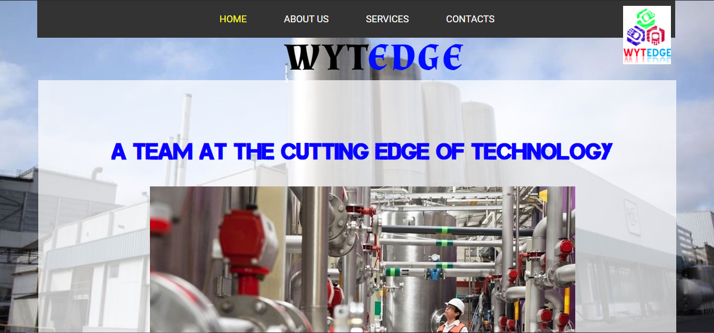

Figure : WYT Edge Website

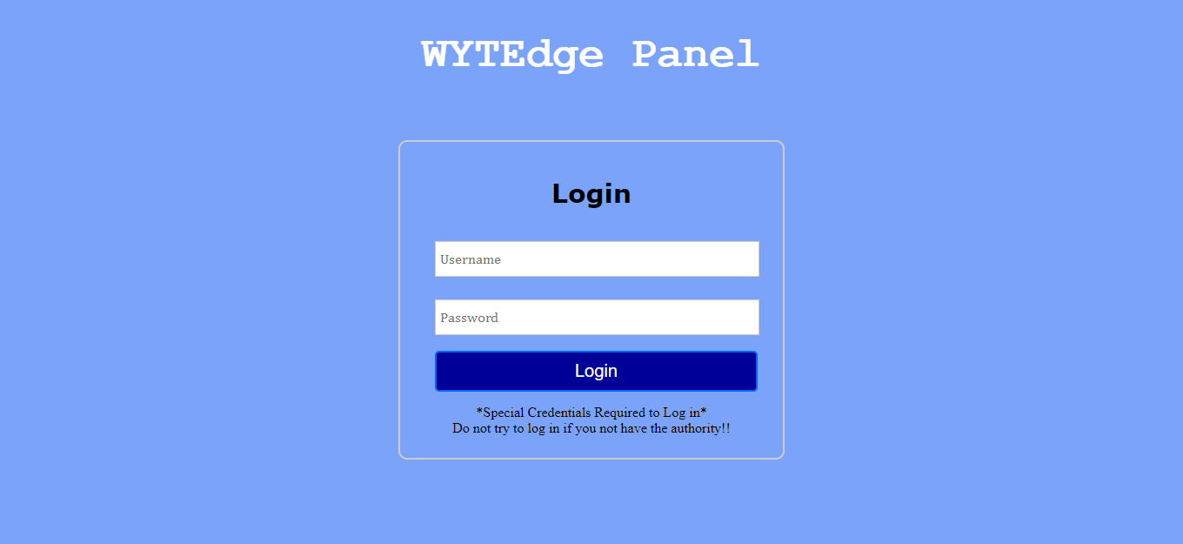

Figure :WYT Edge Panel

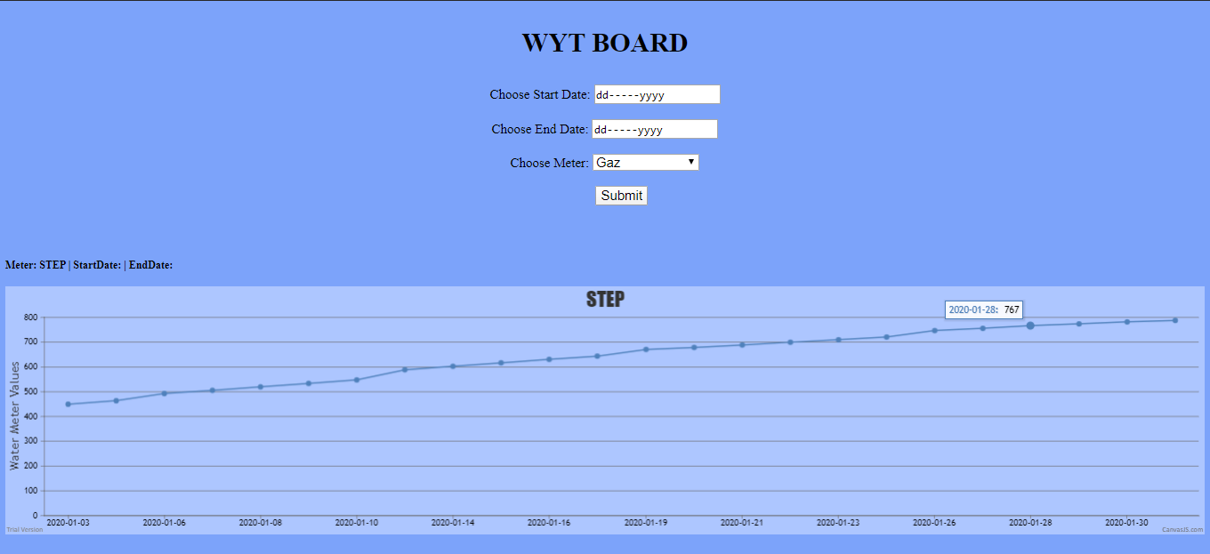

Figure : WYT Board

# Conclusion

The aim of the internship was successfully met, which is providing students with exposure to working life as well as the working environment. During my course of placement at MPL, I learnt many skills which will help me throughout my whole life. I have been able to work on several projects, as explained in this report within tight deadlines and also using proof of concepts to validate ideas.

While working on the WYT Edge Project, I learnt basic electronics which are:

* Units of measurement: Voltage, Ampere, Resistance, Power, Ohms, etc…
* How to calculate resistance using resistor’s colour code
* Building Circuits: How to draw circuits, how to analyse a circuit, how to build one
* How resistors, capacitors, and IC work
* Using Arduinos, GSM Modules, Ethernet Shields, LCD screens and many more…

I have also put my Android programming (JAVA) skills into practice by coding the WYT Edge Android App.

Furthermore, I was able to practice my web coding skills too by building the WYT Edge website, WYT Edge Panel and WYT Board. I used PHP to code APIs which made the whole connection possible. I also made use of HTML, CSS, JavaScript and Bootstrap 3 for the website.

When I was working on AI Game Project, I developed my python skills further by putting into practice my Python OOP.

Moreover, I have also been able to learn about formal rules of the working environment like punctuality, reporting hierarchy, roles of different departments, etc

Finally, I have learnt a lot in the areas of IoT and big data with situ application. Most importantly, I was able to learn about codes of conduct and formal communication which are crucial at work.

# GLOSSARY

**Arduino Uno:** The Arduino Uno is an open-source microcontroller board based on the Microchip ATmega328P microcontroller and developed by Arduino.cc. The board is equipped with sets of digital and analog input/output pins that may be interfaced to various expansion boards and other circuits. – Wikipedia**.**

**C++:** High-level, general-purpose programming language.

**Encryption:** It is the process of encoding a message or information in such a way that only authorized parties can access it and those who are not authorized cannot.

**Ethernet:** Ethernet is the traditional technology for connecting devices in a wired network, enabling them to communicate with each other via a protocol.

**GSM:** It is the global standard for mobile communications.

**GPRS:** GPRS is a mobile service on the 2G and 3G cellular communication.

**MYSQL:** open-source relational database management system.

# List of Abbreviations

**API:** Application Programming Interface

**CS:** Chip Select pin

**GSM**: Global System for Mobile Communications

**GPRS**: General Packet Radio Service

**IC:** Integrated Circuit

**IP:** Internet Protocol

**OOP:** Object Oriented Programming

**RX:** Receiver UART Pin

**SSL:** Secure Socket Layer

**TCP:** Transmission Control Protocol

**TX:** Transmitter UART pin

**UDP:** User Datagram Protocol

**UART:** Universal Asynchronous Receiver/Transmitter

BLANK